Joe Nolan - Carlow GAA Hall of Fame Award
posted 23 Jan 2017, 14:01 by PRO St Pats,Tullow,Carlow
Congratulations to our own Joe Nolan on receiving his Carlow GAA Hall of Fame Award last night at the 2016 season awards night at Mount Wolseley on Sat 21 Jan 2017. Joe played in goal for Tullow and Carlow in the 60s and was one of the finest keepers to ever wear the Carlow jersey. He was selected as goalkeeper on the Carlow Football Team of the Millenium back in 2000 and last night's award gives him the full collection of what any garlic footballer in Carlow could receive. Joe is a big commanding figure and is one of the all time greats.
Joe is currently living in Graigcullen, he is a gentleman and a worthy winner of this award.
Conor Lawlor from Paletine received the senior footballer award for 2016 with Seamus Murphy from St. Mullins receiving his second hurling award.

Please support the lads in the 1916 reenactment of the Senior County Final!
posted 1 Apr 2016, 14:44 by PRO St Pats,Tullow,Carlow
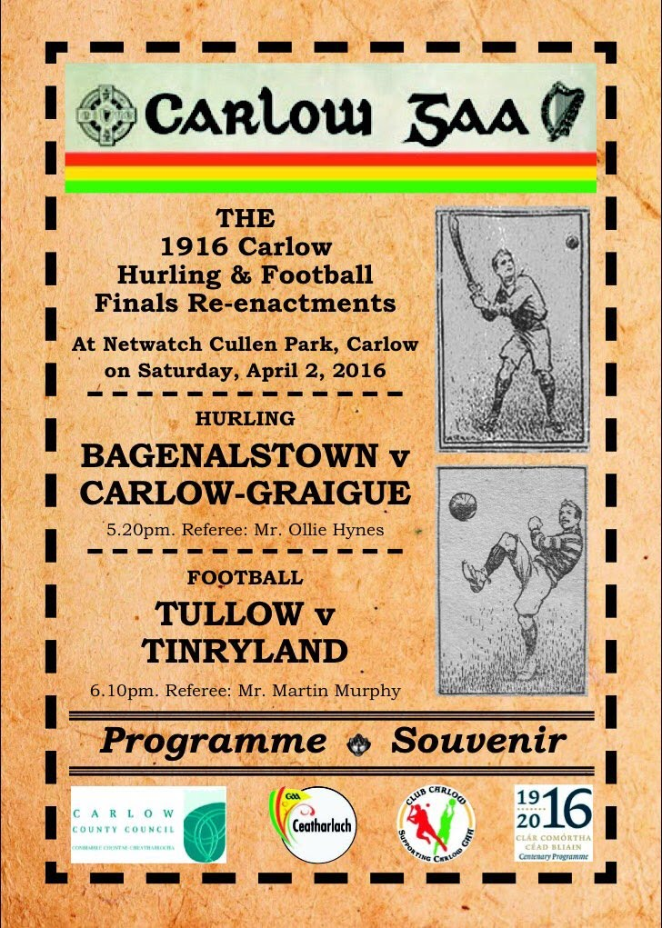

St Patricks Montage of teams past and present, kindly put together by Ray Flynn!
posted 16 Mar 2016, 09:00 by PRO St Pats,Tullow,Carlow
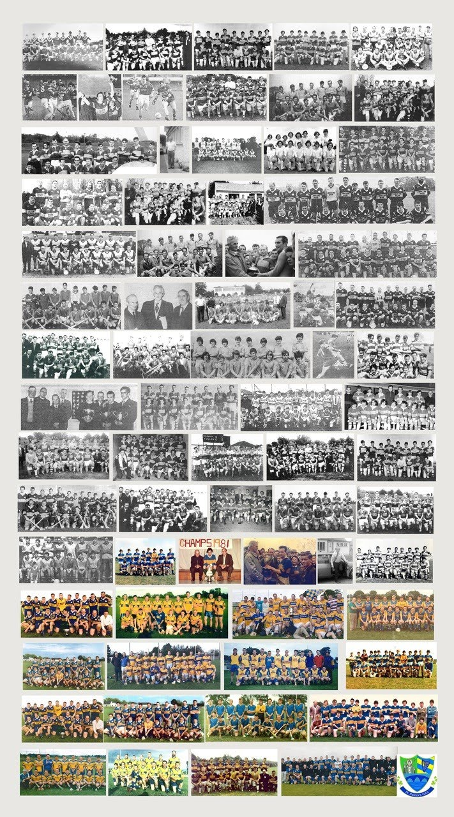

GOAL Mile
posted 10 Dec 2015, 13:39 by PRO St Pats,Tullow,Carlow [ updated 10 Dec 2015, 13:40 ]
Goal mile will take place St Stephens day in Bro Leo Park. From 10:00am until 13:00.
All proceeds go to GOAL.

| Attachments: GOAL_Mile.jpg

Club Awards Night
posted 1 Dec 2015, 18:03 by PRO St Pats,Tullow,Carlow
The St Patricks Club awards night is on this Friday 4th of December from 9pm to 10pm in Mrs Leavys Bar, Tara Arms, Tullow.

The minors will be receiving their championship medals as well as all the Player of the Year awards for the Junior A's and Junior C's.

Hope to see all members there and new members welcome!

Div 5 Stats 2015
posted 15 Jun 2015, 10:38 by PRO St Pats,Tullow,Carlow
Total of 8 games, WO received from Kilbride, WO given to Fenagh.
Name | Matches played(+ sub app) | Total Scores
Gary Maxwell | 8 | -
Anto Moran | 8 | 0-2
Stephen Hogan | 7 | 0-3
Ebbie Quigley | 6 | -
Ruan Caffery | 6(+1) | -
Sham Comerford | 6 | 0-1
Paul Canavan | 6 | 2-1
Dave Brady | 6 | -
Blain Cosgrove | 5(+2) | 1-1
Johnny Tobin | 5 | -
Owen Doyle | 5 | 0-6
Noel Goss | 4(+2) | 1-6
Ben Hade | 4(+1) | 3-6
Lorcan O’Toole | 4(+1) | 0-6
Stephen Byrne | 4 | 1-5
Willie O’Brien | 4 | 2-3
Colm Kenny | 4 | 0-5
John Fitzgerald | 3 | 0-4
Paul Sheppard | 3 | 0-2
Derry Nolan | 3 | 0-1
Stephen Garry | 2(+1) | -
Craig Tumbles | 2(+1) | 1-1
Jack Ryan | 2 | -
Peter Fitzgerald | 1(+1) | -
Sean Brophy | 1(+1) | 0-1
Lee Byrne | 1(+1) | 1-1
Willie Nolan | 1 | 1-1
Richie O’Leary | 1 | -
Keith Dore | 1 | 1-0
Mark Doran | 1 | -
Michael Byrne | 1 | 0-1
James O’Connor | 0(+1) | 0-1
Stephen Cleary | 0(+1) | 0-1
James O’Brien | 0(+1) | -

Div 3 Stats 2015
posted 15 Jun 2015, 10:37 by PRO St Pats,Tullow,Carlow
Total of 7 games, WO received from Pal. Lost the final to Eire Og.
Name | Matches played(+ sub app) | Total Scores
James Tobin | 7 | -
Lee Kavanagh | 7 | -
Willie Doran | 7 | 0-13
Jamie Ansboro | 6 | 1-0
Darren Butler | 6 | 1-2
Paul Rooney | 6 | 3-3
Lee Byrne | 6 | -
Lorcan O’Toole | 5(+1) | 0-4
Padraig Murphy | 5 | 0-6
Frank Wallace | 5 | -
Jack Kennedy | 5 | 1-38
Shane Rohan | 5 | -
Nick Nolan | 4 | 0-2
Shane Farrell | 4 | 1-0
Willie Nolan | 4 | 0-5
Gary Maxwell | 3(+1) | -
Paul Shepard | 3(+1) | 1-4
Josh Doyle | 3 | 2-4
Danny McMahon | 3 | -
Ben Hade | 2(+2) | 1-5
Brian Kenny | 2(+2) | 0-1
Stephen Nolan | 2(+1) | 0-2
Eoin O’Toole | 2(+1) | 2-4
Owen Doyle | 1(+1) | 1-2
Colm Kenny | 1 | -
Sham Comerford | 0(+5) | 0-1
Allan O’Neill | 0(+1) | 1-0
Stephen Byrne | 0(+1) | -
Willie O’Brien | 0(+1) | -
John Fitzgerald | 0(+1) | -

FL Div 5 Round up 05/05/15
posted 7 May 2015, 10:57 by PRO St Pats,Tullow,Carlow
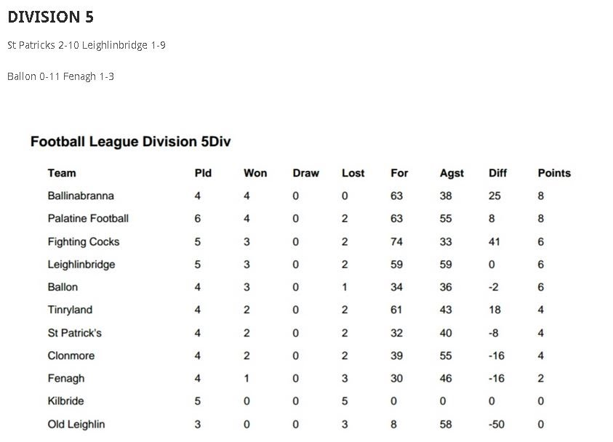

FL Div 3 Round up 05/05/15
posted 7 May 2015, 10:56 by PRO St Pats,Tullow,Carlow [ updated 7 May 2015, 10:56 ]
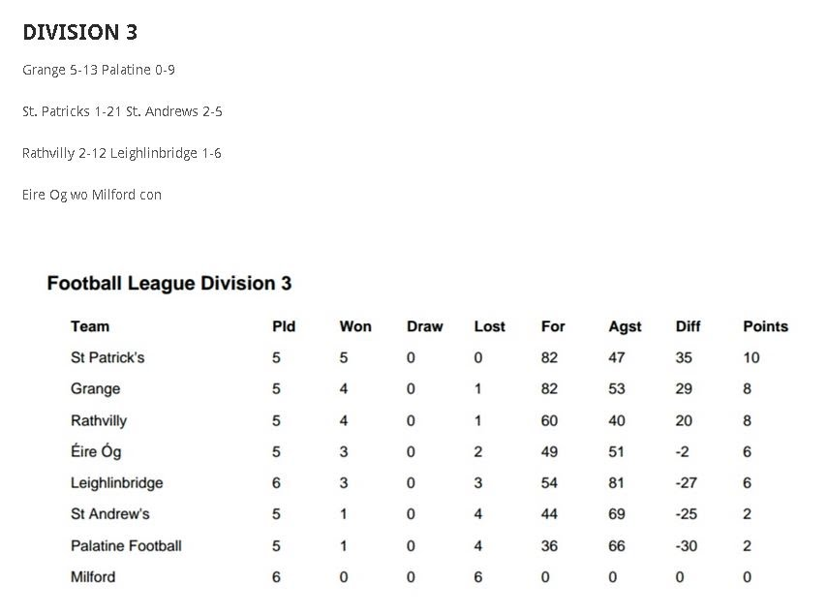

Bro. Leo Park - 4th Annual 5km 2015 Results
posted 20 Apr 2015, 11:40 by PRO St Pats,Tullow,Carlow
Tom Hogan 1557 (1st Male)
Niall Harvey 1638 (1st Minor Male)
Larry Murphy 1653 (1st o/40 Male)
Dean Holmes 1759
Ruairi O’Connor 1915
Dena Hogan 1919 (1st Female)
Pat Sinnot 1935
Chloe Nolan 1940 (1st Minor Female)
Zoe Garrigan 1952 (1st Juv Female-11 years old)
Tony Gartland 2017 (1st o/50)
Keith Butler 2019
Charlie Curran 2020
Stephen Metcalfe 2037
PJ Doyle 2105 (1st o/45)
Dennis Lyons 2138
Mick Hade 2144
Brid Long 2207 (1st o/40 Female)
Lee Kavanagh 2209
Ken Byrne 2232
Michael Doyle 2248
Oisin O’Connor 2342
Stephen Fleming 2349
Pamela Hayden 24:02
Joanne Murphy 2419
Paul Byrne 2420
Ian Carroll 2421
Eddie Coleman 2425
Noelle Bolger 2439
Carol Murphy 2450
Peter O’Connor 2510
Nikki Butler 2523
Donnacha Cunnane 2526
Matthew Breen 2527
Samantha Byrne 2600
Stephanie Corcoran 2607
Sylvia Corcoran 2607
Edel 2614
Nathan Maher 2633
May Doyle 2642
Michelle Byrne 2709
Laura Doran 2735
Caroline Davis 2745
John Farrell 2808
Niamh Farrell 2808
Liz Larkin 2809
Kyle Mulhall 2820 (1st Juv Male-11 years old)
John Mulhall 2821
Mary Behan 2828
Nicola McEntee 2831
Ashley Shannon 2855
Clodagh Hutton 2855
Teegan Joyce 2855
Rebecca Sherratt 2857
Cathy Allen 2859
Rebecca Lawlor 2927
Cahaill Healy 2949
Tracey O’Sullivan 2948
Shane Murphy 2950
Chris Maher 2959
Lorraine Maher 3000
Lisa Rooney 3001
Dermot Walsh 3001
Niall Healy 3013
Evie O’Toole 3015
Helen Whelan 3015
Trish O’Toole 3015
Karen Coleman 3015
Sharon Carew 3055
Therese Nolan 3055
Niamh Murphy 3055
Chloe Murphy 3055
Cian Murphy 3059
Angela Archibald 3114
Kathleen Nolan 3114
Laura Murphy 3140
Eina Pawlak 3140
Sarah Dowling 3200
Eamon Dowling 3200
Emma Butler 3243 (1st Pram)
Hannah Doyle 3258
Ella Lynam 3324
Josh Byrne 3324
Caroline Gahan 3324
Mairead faulker 3324
Gillain Maher 3340
Rachel Farrell 3340
Louise Farrell 3352
Sharon Hennessy 3352
Samantha Faulker 3420
Antoinette Kavanagh 3429
Damien Bolger 3430
Yvonne Foley 3440
Ester Maher 3440
Katelyn Dunne 3540
Linda Dunne 3541
Lisa Hutton 3819
Brian Hutton 3820
Lauren Byrne 3845
Gillian Curran 3845
Anna Butler 3855
Jacinta Walsh 3855
Lisa Brennan 3915
Ann Marie Fitzgerald 3915
Brenda Fitzgerald 3915
Tina O’Dwyer 3945
Ina Dwyer 3945
Ed Fitzgerald 4103
Robin Sheratt 4129
Susanne Sheratt 4129
Laura Hutton 4140
Mandy Darcy 4309
Faye Darcy 4309
Debbie Carthy 4315
Mary Hutton 4315
Ailise Doyle 4357
Marianne Madden 4416
Tim Madden 4416
Mary Coady 4416
Sarah Doran 4416
Killian Faulker 4517
Ray Healy 4550
John Lynam 4550
Margaret Kirwan 4601
Mary Metcalfe 4619
Catherine Murphy 4619
Mia Nolan 4658
Kacey O’Neill 4658
Mel Dawson 4703
Tadhg Madden 4710
Tina Dempsey 4710
Rocky Demspey 4710
Maura Jackman 4806
Catriona Bolger 4807
Miriam Dempsey 4807
Mary Walsh 4943
Brendan Dowling 4943

Div 3 Stats 2014
posted 17 Jul 2014, 08:23 by PRO St Pats,Tullow,Carlow
(excluding final v Rathvilly not played yet) Total scored; 10 goals 116 points Played 8- Won 6, Lost 2

1. Pats 2.22 Milford 0.3
2. Pats 3.18 Leighleinbridge 2.3
3. Pats 1.14 Pal 0.9
4. Pats 2.13 Ballon 1.7
5. Pats 0.19 Railyard 0.12
6. Pats 0.12 Eire Og 2.12
7. Pats 1.7 Rathvilly 4.7
8. Semi Final Pats 1.11 Railyard 0.8

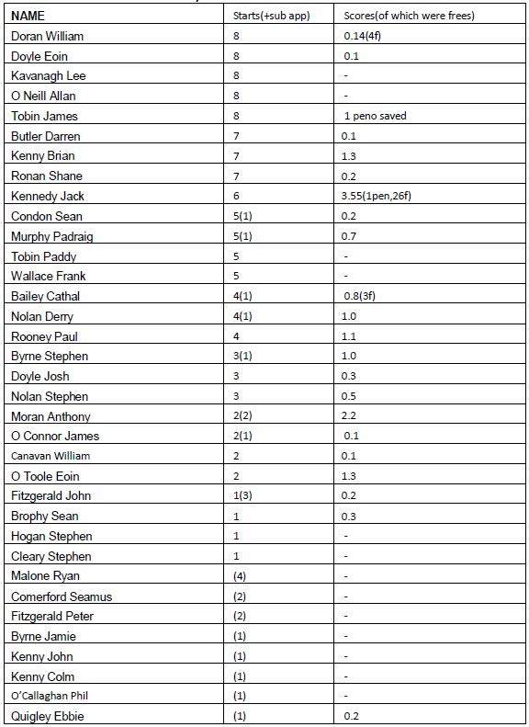

FL Div 5 2014, Appearances and scorers.
posted 5 Jun 2014, 15:33 by PRO St Pats,Tullow,Carlow [ updated 5 Jun 2014, 15:39 ]
Most appearances Ebbie Quigley,
Top scorer Phil O’Callaghan.

St Pats beat- Grange, Leighlinbridge, Tinyryland, Old Leighlin.
St Pats lost to- Myshall, Clonmore, Cocks, Ballinabranna, Ballon.
(St Pats received WO from- Fenagh, Palatine, Kilbride.)

NAME | Starts(+subs). Max score is 9 | Scores(of which were frees)
Quigley Ebbie | 9 | -
Hogan Stephen | 7(+2) | 0-1
Brady David | 8 | -
Doyle Eoin | 8 | 0-3
Comerford Seamus | 8 | 0-4(0.1f)
Malone Ryan | 8 | -
Maxwell Gary | 8 | -
Moran Anthony | 7 | 0-2
Dooley Gerry | 6(+1) | 0-1
Sheppard Paul | 6(+1) | 1-3
Nolan Derry | 6(+1) | 0-3
Byrne Stephen | 5(+2) | 1-12(0.3f)
Garry Stephen | 5(+2) | 0-2
Byrne Jamie | 4(+3) | 1-1
O’Callaghan Phil | 6 | 4-6
Garry Jamie | 5(+1) | 0-5
Goss Noel | 3(+2) | 2-7(0.2f)
McMahon Danial | 3(+1) | 0-1
Ansboro Jamie | 3(+1) | 0-2
Brophy Sean | 1(+3) | 1-3
Canavan Paul | (+4) | 2-2
Cleary Stephen | (+4) | 0-1
Bailey Cathal | 3 | 2-3
Condon Sean | 3 | -
Madden Cian | 2(+1) | 0-1(0.1f)
Dore Keith | (+3) | 0-1
Smyth Thomas | 1(+1) | 0-1
Byrne Lee | 2 | 1-1
Canavan William | 2 | 0-5(0.2f)
Kenny Brian | 2 | 0-1
Smyth Sean | (+2) | -
Nolan Stephen | 1 | 0-2
Byrne Robert | 1 | 1-0
Hade Conor | (+1) | -

5km Fun Run Wed 9th April 7pm Bro Leo Pk
posted 28 Mar 2014, 11:57 by PRO St Pats,Tullow,Carlow
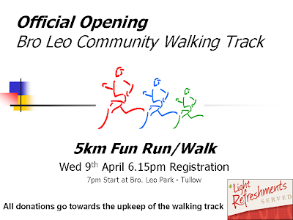

Training & Match Schedule Bro Leo Pk June & July
posted 27 May 2013, 10:17 by PRO St Pats,Tullow,Carlow
June
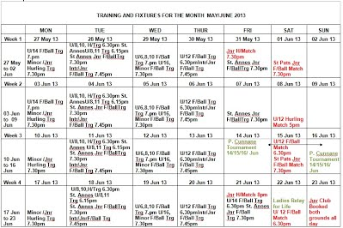
Click on image to expand
July
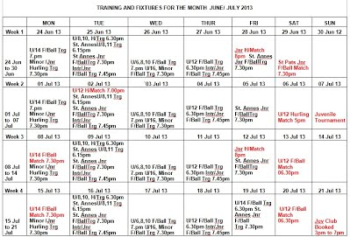
Click on image to expand

Fun Run Tomorrow Night Reg from 6.30pm!
posted 21 May 2013, 12:32 by PRO St Pats,Tullow,Carlow
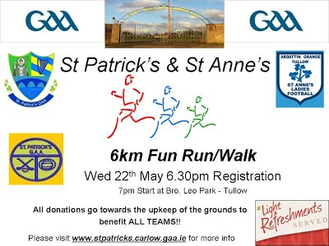

Spin & Win results 20/05/13
posted 21 May 2013, 12:30 by PRO St Pats,Tullow,Carlow

Winners

€100 Eddie Kelly Ballyhackett Tullow

€50 Rose Ward The Square Tullow .
€25 James Clarke Tullowbeg Tullow

Promoter Tom Fitzgerald
Next Draw – Mon 03/06/2013
Ardattin Inn

Jackpot 12.500=00

Spin and Win Results 6/05/13
posted 10 May 2013, 10:10 by PRO St Pats,Tullow,Carlow
St. Patrick’s G.A.A. Tullow

Draw results: 06/05 2013

€12.500

€100 John Cole Liscolman Tullow

€50 Celest Crawford Collins Crab Lane

€25 Gerry Connolly Shilleagh Groove Tullow

Promoter Chris Murphy

NEXT DRAW 20/05/2013

Hogan Stand Bar
Tickets: €2.00 each ON SALE HERE

GAA Club Newsletter May
posted 1 May 2013, 13:18 by PRO St Pats,Tullow,Carlow
http://gaa.createsend5.com/t/ViewEmail/r/4B9101839E35A23A2540EF23F30FEDED/8B28B3F4B80E1ED616FB8100885F948E

Spin & Win Results 22/04/13
posted 29 Apr 2013, 10:54 by PRO St Pats,Tullow,Carlow
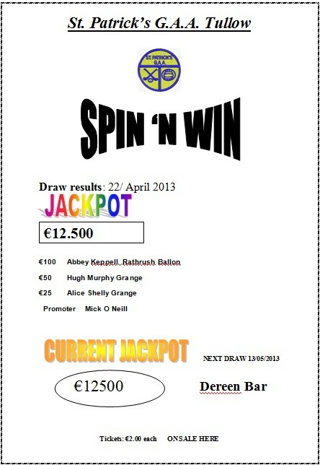

Training & Fixtures in Bro Leo Pr for May
posted 29 Apr 2013, 10:51 by PRO St Pats,Tullow,Carlow
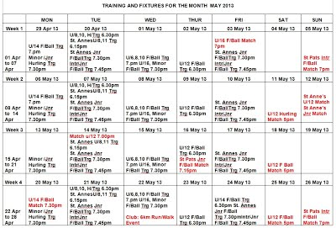
Please click on image to expand

Spin & Win
posted 9 Apr 2013, 11:27 by PRO St Pats,Tullow,Carlow

Draw results: 08/ April 2013

€100 Des Byrne Ballour Ballom

€50 Rita Murphy Palatine Bowls

€25 Ger Dalton Bridge Street

Promoter Tom Fitzgerald

NEXT DRAW 22/04/2013 in JJ's Bar
Jackpot - €12,500
Tickets: €2.00 eachon sale from Club Promotors

Medical & Player Welfare
posted 2 Apr 2013, 11:44 by PRO St Pats,Tullow,Carlow
Lads,
Please take note of this, it is very important that everyone understands where they stand should they get injured during the year.

Medical & Player Welfare
Sports Injuries in the G.A.A.
Virtually any part of your body can be injured in Hurling or Gaelic Football which can result from accidental collisions, poor training practices, lack of conditioning or insufficient warm-up routines.
Common Types of Sports Injuries
• Muscle sprains and strains e.g. calves, hamstrings etc.
• Tears of ligaments that hold joints together e.g. cruciate
• Tears of the tendons that support joints and allow them to move e.g. bicep tendon in the arm
• Dislocated joints e.g. shoulder/ knee
• Fractured bones, including vertebrae in the spine e.g. ankle, leg or arm
G.A.A. Insurance & Injury Scheme
The Player Injury Scheme provides the club officials and relevant Insurance administrators to register teams with The Player Injury Scheme. All details are now recorded online allowing the various club officials and administrators in Croke Park to view signed up members of each club readily at the touch of a button.
Why is this Important for the player?
It records all data entered by the relevant club officials designated within each club. There is a table which lists the names and details of all paid up members. This contains information relating to your insurance cover and when the money was submitted e.g. date of payment. On payment each player will receive his/her unique PIS number. Any outstanding amounts are also recorded, the details of which are submitted to both Croke Park and The Player Injury Scheme.
Serious Injuries requiring Medical attention or Surgery
The Player Injury Scheme cover is on a calendar basis and runs from Jan 1 to Dec 31 of each year. Players seeking to make claims based on injuries suffered either in training or on the field of play must have Insurance cover on the relevant date. Injuries must be reported to club officials so that the procedure can commence. This will detail the nature of the injury sustained along with details including the date and time of the incident. In the case of a match situation the referees report will be requested detailing the nature and time of the incident.
In all cases the Exact date of the injury must be recorded and specified in relation to the incident. All details must be entered on the G.A.A. Injury Claim Form. Failure to do so will result in non payment to players for medical/dental bills and also regarding loss of wages incurred.
Further details of the Player Injury Scheme can be secured from:
John Kenny 087 7956977
Or
Willis, Grand Mill Quay, Barrow Street Dublin 4. Ph 01 6396343
E mail: gaa.queries@willis.ie
Failure to pay Membership will result in No Insurance Cover

Regards,
John Kenny
Medical & Player Welfare Officer

Junior & Intermediate League Fixtures
posted 2 Apr 2013, 11:42 by PRO St Pats,Tullow,Carlow
FOOTBALL LEAGUE 2 2013

Date | Teams | Round | Remarks
07/04/13 (Sun) | St. Patrick’s v Ballon | Rd 1 | 18.30
14/04/13 (Sun) | Grange v St. Patrick’s | Rd 2 | 18.30
21/04/13 (Sun) | St. Patrick’s v Leighlinbridge | Rd 3 | 18.30
26/04/13 (Fri) | Éire Óg v St. Patrick’s | Rd 4 | 19.30
05/05/13 (Sun) | St. Patrick’s v Clonmore | Rd 5 | 19.00
12/05/13 (Sun) | Fenagh v St. Patrick’s | Rd 6 | 19.00
17/05/13 (Sun) | St. Patrick’s v Bye | Rd 7
26/05/13 (Sun) | St. Patrick’s v Railyard | Rd 8 | 19.00
02/06/13 (Sun) | Ballinabranna v St. Patrick’s | Rd 9 | 19.00

FOOTBALL LEAGUE 3 2013

Date | Teams | Round | Remarks
06/04/13 (Sat) | Tinryland v St Patrick’s | Rd 1 | 18.30
13/04/13 (Sat) | St. Patrick’s v Rathvilly | Rd 2 | 18.45
20/04/13 (Sat) | Maomh Moling v St. Patrick’s | Rd 3 | 18.45
27/04/13 (Sat) | St. Patrick’s v St Andrew’s | Rd 4 | 18.40
04/05/13 (Sat) | St. Patrick’s Bye | Rd 5
11/05/13 (Sat) | Kildavin/Clonegal v St. Patrick’s | Rd 6 | 19.15
16/05/13 (Thur) | St. Patrick’s v Milford | Rd 7 | 19.15
28/05/13 (Tue) | Askea v St. Patrick’s | Rd 8 | 19.30
01/06/13 (Sat) | St. Patrick’s v O Hanrahans | Rd 9 | 19.30
08/06/13 (Sat) | Old Leighlin v St. Patrick’s | Rd 10 | 19.30
15/06/13 (Sat) | St. Patrick’s v Palatine | Rd 11 | 19.30
22/06/13 (Sat) | Éire Óg v St. Patrick’s | Rd 12 | 19.30
29/06/13 (Sat) | St. Patrick’s v MLR | Rd 13 | 19.30

Training & Fixtures for April in Bro Leo Park
posted 2 Apr 2013, 11:41 by PRO St Pats,Tullow,Carlow
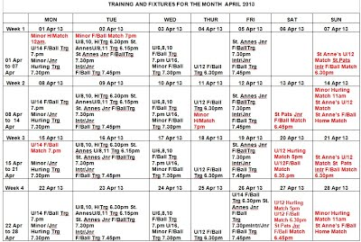
Click on image to expand!

Training & Fixtures for March in Bro Leo
posted 25 Feb 2013, 15:42 by PRO St Pats,Tullow,Carlow
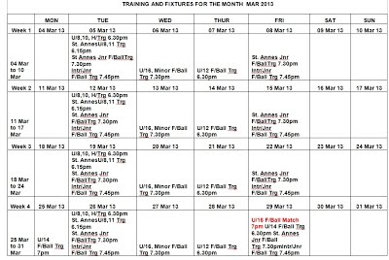
Please click on image to enlarge!

Committee 2013
posted 23 Jan 2013, 09:25 by PRO St Pats,Tullow,Carlow
The AGM was held on Sat the 19th of Jan
We had a great turnout and the following were elected onto the committee for 2013
President | Fr. Andy Leahy
Vice Presidents | Jim Kirwan, Bill Canavan, Tony Maher, Sean Nolan
Chairman | Chris Murphy
Vice Chairman | Tadhg Madden
Secretary | Mick O'Neill
Treasurer | Frank Wallace
PRO | Lorcan O'Toole
Commitee Members | James Tobin, Darren Butler, Bro. Bosco, Tom Fitzgerald,  Padraig Murphy, Máirtín Mulooney, John Kenny
Registrars/Membership | John Kenny
County Board Delegate | Máirtín Mulooney
Assistant Secretary | Peter Fitzgerald

Spin & WIn Results
posted 20 Dec 2012, 08:16 by PRO St Pats,Tullow,Carlow
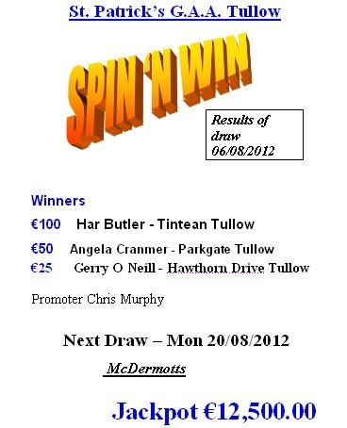

Nollaig Shona
posted 17 Dec 2012, 08:54 by PRO St Pats,Tullow,Carlow
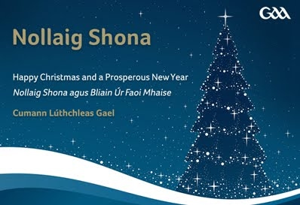

As another busy year draws to a close we would like to take this opportunity to wish everyone a very happy Christmas and prosperous New Year.
The festive season is one of the few quieter times in our busy calendar, a time for reflection and a time to enjoy the company of family and friends.
A special word of thanks to our players, members, officials, volunteers, supporters and sponsors for all you do to help promote our games and culture during the year and best wishes for 2013.

Nollaig Shona agus Athbhliain faoi Mhaise.

New RTE wedding show looking for star couple and their MOTHERS!...
posted 12 Dec 2012, 13:42 by PRO St Pats,Tullow,Carlow
Hi all, for some of you Celeb Bainisteoir is a distant memory, for others more recent, but we are on the hunt for the stars of a new show. Anyone in and around the club wanting to get married next Spring, and Christmas engagements on the cards...anyone want to give their mothers 10,000 to organise their big day? That's all we need, a great couple and two willing, mothers/mother in law to be!
email to weddings@animo.ie

Deadline for entries is December 19th, 2012. See below for more details...
NEW RTÉ SHOW – LOOKING FOR CONTRIBUTORS
<!--[if !supportEmptyParas]--> <!--[endif]-->
“The Mother Of All Weddings”
GETTING MARRIED?
STRESSING ABOUT THE ARRANGEMENTS?
<!--[if !supportEmptyParas]--> <!--[endif]-->
COULD YOU DO WITH SOME CASH IN THE KITTY…SAY €10,000!
WOULD YOU RATHER IT WAS ALL HANDLED BY OTHERS…IF THOSE OTHERS WERE YOUR MOTHER AND MOTHER IN LAW TO BE?
<!--[if !supportEmptyParas]--> <!--[endif]-->
<!--[if !supportEmptyParas]--> <!--[endif]-->
Sound good? Then, we'd love to hear from you. We're making a brand new TV show for RTÉ called “The Mother Of All Weddings” where the bride and groom hand over the reins to their mothers to organise their big day.
<!--[if !supportEmptyParas]--> So, what do we need? 4 up for it individuals! Our couple should be planning a wedding spring / early summer 2013. Remember, BOTH Mums organise the day, so we want to speak with you if you have big plans, but nothing yet booked.
Talk to your kids, partners, mothers...get them onboard with the idea… THEN…
Get in touch! Email weddings@animo.ie giving us your contact details and few lines about you, your partner and your two mums.
What makes you the perfect fit? How long have you been together? What do you do? Whats special about you and your mothers? Why would the show make a difference to you and your big day?
If you can, send us a little video clip of you in action. (60 second max!)

Amanda, Casting Producer
e: weddings@animo.ie

Produced by Animo TV & Kite Entertainment, the makers of Celebrity Bainisteoir and Secret Millionaire “The Mother Of All Weddings” will be a uniquely Irish take on the ever popular area of wedding programmes. You’ll be in good hands.

St Pats Juveniles
posted 4 Dec 2012, 19:03 by Unknown user
Well done to St Pats Juveniles on their recent victory in the Garda Tournament!
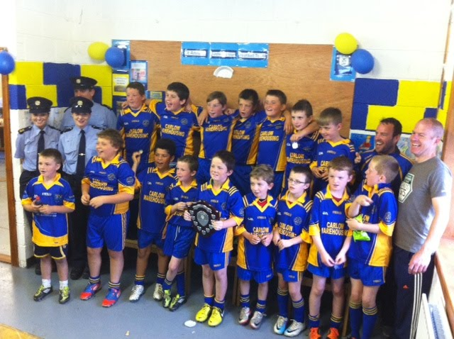

inner Dance Award Winners were as follows:
posted 4 Dec 2012, 18:43 by PRO St Pats,Tullow,Carlow
Well done to all the award winners at our Dinner Dance on the 1st of December

Award Winners were as follows:

St Patrick’s
Intermediate Player of the year: Jack Kennedy
Junior Player of the year: Gerry Dooley
Young player of the year: Sean Condon
Joint Hall of Fame: Bro. Bosco & Bro. Nickolas
Special Recognition: Chris Murphy
Joint Clubmen of the year: Tadhg Madden & Padraig Murphy

St Anne’s
Junior Player of the year: Lorraine Dempsey
Joint young players of the year: Denise Doran & Niamh Byrne
Club person of the year: Deirdre Keppel
Appreciation Award: Bernie Cunnane

Special thanks to Paul Rooney our official photographer on the night!

New info on Mouthguards and the GAA
posted 29 Nov 2012, 09:04 by PRO St Pats,Tullow,Carlow
Please see information for clubs, players and parents in relation to the use of mouthguards
Mouthguards and the GAA
Information for Clubs, Players and Parents

BACKGROUND
Following the GAA’s Annual Congress in April 2012 a new rule was enacted that made it mandatory to use a mouthguard in all Gaelic football matches and training sessions from January 1st 2013 (for all age grades up to and including minor) and at U21 and Adult level from January 1st 2014.

Research figures indicate that Ireland has one of the highest rates of sport-related oral injuries in the EU, with one third of all adult dental injuries being sports-related. In many sports such as rugby and hockey the wearing of gumshields is the norm with nearly all clubs adhering strictly to a 'no gumshield - no game' rule. A recent survey of Irish parents found the average cost of dental treatment for sport related dental injuries in children to be €213.14. Studies have also shown that the overall injury risk is close to twice as high when a mouthguard is not worn, relative to when mouthguards were used during athletic activity.

The GAA’s Medical, Scientific & Welfare Committee acknowledge that the use of a properly fitted mouthguard is the best available protective device for reducing the incidence and severity of sports-related dental injuries and was centrally involved in ensuring the introduction of compulsory mouthguards in Gaelic Football.

This information sheet has been compiled to assist GAA Clubs and individual players in complying with the provisions of the new rule passed at Congress 2012.

ABOUT MOUTHGUARDS
There are three types of mouth guards:
Stock mouthguards are preformed and come ready to wear. They are inexpensive and can generally be purchased in sports shops for in or around €5 each. However, little can be done to adjust their fit, they are bulky, can make breathing and talking difficult, and they provide limited protection. Dentists do not recommend their use, nonetheless, once they carry the CE (European Conformity) mark they are acceptable in terms of complying with the new GAA Rules.

Official Opro GAA/GPA stock mouthguards will be available for purchasing through your local retailers: Supervalu, Centra, Lifestyle and Elverys.

Boil and bite mouthguards can also be bought over the counter at most Sports Shops and generally offer a better fit than stock mouth protectors. The "boil and bite" mouthguard is made from thermoplastic material. It is placed in hot water to soften, then placed in the mouth and shaped around the teeth using finger and tongue pressure. Dentists do not recommend their use in general. Typically these type of mouthguards will cost in the region of €15 to €20 and again any mouthguard with the CE mark on it in this category is sufficient to ensure compliance with the new rule.

Official Opro GAA/GPA boil & bite mouthguards will be available for purchasing through your local retailers: Supervalu, Centra, Lifestyle and Elverys.

Custom-fitted mouthguards are individually designed and made in a dental office or a professional laboratory based on your dentist's instructions. These will not just offer the best protection against dental and oral injury but they should not affect performance i.e. breathing and speech should be relatively unaffected particularly if these have been worn regularly.

First, your dentist will make an impression of your teeth and a mouth guard is then molded over the model using a special material. Due to the use of the special material and because of the extra time and work involved, this custom-made mouth guard is more expensive than the other types, but it provides the most comfort and protection.

Prices can vary significantly and it is worth seeking and comparing prices from a number of practitioners before deciding to purchase. Typically a custom fitted mouth-guard should cost between €60 and €120. However, many dental practices offer significant reductions to GAA Clubs who are ordering in bulk. GAA clubs can generally liaise with dental centres and clinics to arrange for someone to visit the club on a given day to take dental impressions from a number of players. Custom fitted mouthguards purchased in bulk in this manner should cost around €30 to €50 each.

To find a list of dentists and dental centres in your area, you can use the Find a Dentist function on the Irish Dental Associations Website - http://www.dentist.ie/find-a-dentist.10.html

WHICH TYPE OF MOUTHGUARD SHOULD I PURCHASE?
The decision on which type of mouthguard a player should obtain is a matter of personal preference. There is no doubt that custom fitted mouthguards offer the best fit and protection but they are the most expensive option also. The Stock and Boil & Bite options will suffice for compliance with the new rules, but only if the product carries the CE mark.

In terms of underage players, it should be borne in mind that teeth and mouths are still developing up until about 12 years of age and young players may grow out of custom fitted mouthguards over a period time. However, your dental practitioner is ultimately in the best position to advise in this context.

COMPLYING WITH THE NEW RULE
The GAA recognise that Clubs may be worried about compliance with the new rules and specifically what will happen if a player forgets or does not have a mouthguard on the day of a game. The suggestion in this context is that each Club should purchase a supply of the Stock or Boil and Bite mouthguards for use in such situations.

If a player refuses to comply with a Referee’s instruction to wear a mouthguard, he will incur the penalty as outlined in (Rule 6.2, Rules of Foul Play, The Playing Rules of Football, Official Guide, Part II, 2012) ‘Caution the offender; order off if he persists’.
SOME QUESTIONS
1. When does the new rule come into effect?
A. From January 1st 2013, all players playing in grades up to and including Minor will be required to wear a mouthguard in all football games and at practice sessions.

2. When does the ruling come into effect for adult players?
A. From January 1st, 2014 all players at all grades will be required to wear a mouthguard in all football games and practice sessions.

3. What will happen if I am not wearing a mouthguard in a game?
A. If a player refuses to comply with a Referee’s instruction to wear a mouthguard, he will initially be cautioned by the Referee and if the player continues to refuse, the Referee can send him off.

4. Who is responsible for ensuring mouthguards are worn at training or practice sessions?
A. It is a matter for each Club to ensure the rule is adhered to at training or practice sessions. Clubs and players should note that Players will not be covered under the player injury scheme if they are not wearing a mouthguard.

5. Do players have to wear a mouthguard in hurling games?
A. No. The new rule only applies to football; however, wearing a mouthguard when playing hurling does reduce the risk of dental injury.

6. I am a Minor playing on an adult team in 2013. Do I have to wear a mouthguard?
A. Not in 2013. The wearing of mouthguards in 2013 is compulsory at all age grades up to minor. However, a player playing at U-21 or adult level in 2013 is not required to wear a mouthguard under rule. From January 1st 2014 all players at all grades must wear a mouthguard.

7. Our Club has a nursery, are children in these juvenile age groups exempt from wearing a mouthguard?
A. No. The Medical, Scientific & Welfare Committee advise that children should begin wearing a mouthguard at whatever age they start playing. Young mouths need protecting too and if players start wearing mouthguards at a young age this will add greatly to the development of a culture of wearing mouthguards in Gaelic Football.

8. Does the new rule regarding the wearing of mouthguards apply to Cumann na mBunscol games?
A. Yes.

9. If so, who is responsible for ensuring that they should be worn?
A. In general it is a matter for each Club to ensure this; however, in this case it is a matter for each School to ensure the rule is adhered to at training or practice sessions. To avoid a scenario whereby children may forget their mouthguard, the GAA recommends that Schools purchase a reserve of stock mouthguards.
10. Do I have to wear a mouthguard whilst playing Second Level games?
A. Yes. From January 1st 2013, all Second Level players will be required to wear a mouthguard in all football games and at practice sessions.

11. Do I have to wear a mouthguard whilst playing Third Level games?
A. Not in 2013. From January 1st 2014 all players at all grades must wear a mouthguard.

12. Does this apply to overseas players?
A. Yes.

13. I’m a referee – do I have to check all players mouths before a game to ensure compliance?
A. Referee’s will not be expected to individually check players before a game; however, if a Referee notices that a player is not wearing a mouthguard, he should caution the player and if the player still refuses to wear one, he should be sent off.

14. A supplier of custom fitted mouthguards has contacted my club and offered to measure players for custom fitted guards, what does the GAA advise?
A. It is a matter for each individual club to decide whether they want to engage with industry suppliers in this context or not. The GAA nationally has no preferred suppliers in this area.

15. Which type of mouthguard should I purchase?
A. The decision on which type of mouthguard a player should obtain is a matter of personal preference. There is no doubt that custom fitted mouthguards offer the best fit and protection but they are the most expensive option also. The Stock and Boil & Bite options will suffice for compliance with the new rules, but only if the product carries the CE mark.

16. I currently wear orthodontic braces, what are my options?
A. It has been noted that children wearing orthodontic braces and wishing to play Gaelic football will be particularly concerned about the rule change; however, the GAA recommends that these players seek advice from a range of dental practitioners on the most appropriate solution for them.

17. Is there an official GAA/GPA mouthguard?
A. Official Opro GAA/GPA stock and boil & bite mouthguards will be available for purchasing through your local retailers: Supervalu, Centra, Lifestyle and Elverys.

If you have any queries or would like more information, please contact Games & Player Welfare Administrator Ruairí Harvey: Telephone: (0) 1 865 8685; E-mail: ruairi.harvey@gaa.ie

Summer Sports Predictor Results 2012
posted 20 Nov 2012, 11:33 by PRO St Pats,Tullow,Carlow
Each place decided on Tie Breaker Question

Tie Breaker Answer = 76 goals

Entrants answer in brackets

1st – 90 Pts – Stuart Quinn/Shane Forde (43)
2nd – 90 Pts – Noel Goss (168)
3rd – 80Pts – Lydia Burke (77)
4th – 80 Pts – Jim Foley (70)
5th – Frann & Trish (98)

Well done to the U'12s on winning silverware in Ballon recently!
posted 13 Nov 2012, 12:26 by PRO St Pats,Tullow,Carlow
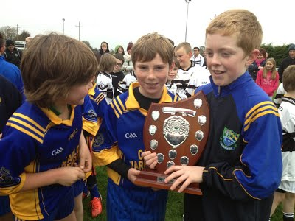
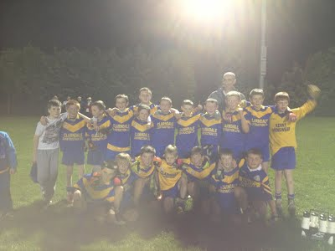
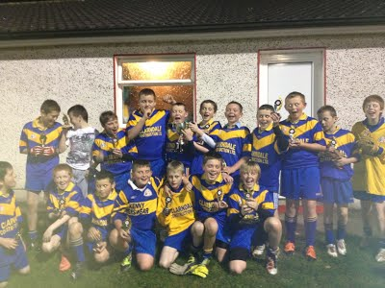

Results of St Pats Golf Classic – Mount Wolseley 22nd Aug
posted 13 Sep 2012, 12:25 by PRO St Pats,Tullow,Carlow
Overall Winners of Golf Classic
1st Place – 97 points
John Byrne
Paul Maher
Sean Maher
Eddie Copeland

2nd Place - 87 points
J.S. Nolan
Liam Nolan
J. Nolan Jnr
D. Fogarty

3rd Place – 86 points
Ed Fitzgerald
Mick Murphy
Con Dempsey
Ed Mulhall

Non GUI Winners – 87 points
Pat Ball
Stephen Culligan
Kevin Tigue
Gary Loughnane

Nearest the pin
6th hole – Danny Smith 41”
9th hole – Ollie Murphy 36”
11th hole – Colm Muldowney 53”
16th hole – Greg Kelleher 18”

IFC Group B Table 24th Aug
posted 6 Sep 2012, 12:49 by PRO St Pats,Tullow,Carlow
Courtesy of Brian O'Donoghue
TALBOT HOTEL INTERMEDIATE FOOTBALL CHAMPIONSHIP GROUP B
Pld Won Draw Lost For Agst Diff Points
Fighting C 4 3 0 1 37 25 12 6
St Patrick's 3 3 0 0 30 27 3 6
Clonmore 4 2 0 2 37 39 -2 4
Ballinabr 4 2 0 2 59 64 -6 4
Askea 3 1 0 2 49 46 -16 2
MLR 4 0 0 4 11 26 -15 0

Celebrity Bainisteoir starts this Sunday at 6.30pm RTE1
posted 5 Sep 2012, 10:15 by PRO St Pats,Tullow,Carlow [ updated 5 Sep 2012, 10:20 ]

About the Show

Everyone's favourite celebrity GAA reality series returns to RTÉ One Television this September and this time things are a little bit harder for our celebrities. There is a whole lot more at stake this year as we introduce Celebrity Bainisteoir - The Rivals which sees each celebrity paired against a rival celebrity from their own world. It's X-factor versus The Voice as singer Mary Byrne takes on Richie Hayes; the battle of UK reality TV as celebrity traveller and celebrity Big Brother winner Paddy Doherty takes on celebrity everything Calum Best; the battle of the babes as WAG Jessica Lawlor goes head to head with model Roz Purcell and it's a Mr and Mrs Celebrity Death Match as married couple Brian Ormond and Pippa O'Connor go to war on the football pitch.
And here's the twist, our losing bainisteoir then has to become the winning bainisteoir's assistant as they progress to the semi-finals. Charged with cleaning the teams boots, taking an extra training session or whatever task the winning bainisteoir chooses for their new assistant, gentle humiliation will be the order of the day as the slagging rights on this one are all to play for.
And that's not all, this year we're also putting the battle for home advantage clearly on the shoulders of our hero celebrities, where it'll be entirely up to each of them to win this all important honour for their club through a series of unique celeb vs celeb challenges.

This year sees Celebrity Bainisteoirs manage the following clubs:
- Paddy Doherty - Scoil Ui Chonaill GAA Club, Clontarf, Dublin
- Calum Best - Moy Davitts GAA Club, Foxford, Mayo
- Mary Byrne - St. Patrick's GAA Club,Tullow, Carlow
- Richie Hayes - Tramore GAA Club, Waterford
- Jessica Lawlor - Ballinora GAA Club, Cork
- Roz Purcell - Newtown Cashel, Longford
- Pippa O'Connor - Naomh Brid GAA Club, Donegal
- Brian Ormond - St Mary's GAA Club, Rochfordbridge, Westmeath
The quarter final matches see the following ties:
Calum Best V Paddy Doherty
Mary Byrne V Richie Hayes - To be broadcast on Sun 23rd Sept at 6.30pm
Brian Ormond V Pippa O'Connor
Jessica Lawlor V Roz Purcell
Celebrity Bainisteoir broadcasts on RTÉ One on Sundays at 6.30pm.

Celebrity Bainisteoir Update
posted 3 Sep 2012, 10:25 by PRO St Pats,Tullow,Carlow
Thursday 6th September
Training at 5pm
All welcome to watch

Friday 7th September
Training at 6pm
All welcome to watch

Sunday 9th September
Challenge between Calum Best and Mary Byrne involving the All Ireland Hurling Final
This is to see which team will get home advantage

Saturday 15th September
Match v Moy Davitts - Venue T.B.C.

Celebrity Bainisteoir match v Tramore Aug 12th
posted 3 Aug 2012, 10:59 by PRO St Pats,Tullow,Carlow
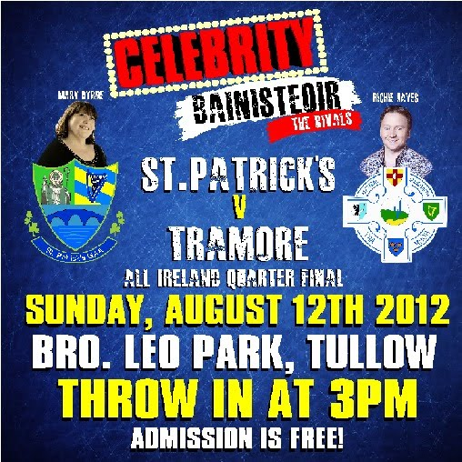

Fundraiser Concert Mount Wolseley Wed 5th Aug
posted 31 Jul 2012, 09:34 by PRO St Pats,Tullow,Carlow
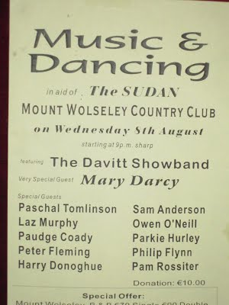

St Patricks GAA Club Summer Sports Predictor
posted 27 Jul 2012, 10:46 by PRO St Pats,Tullow,Carlow
Top Scores & Positions after 12 Events

- 80 Points
Noel Goss
Stuart Quinn
Shane Forde

- 70 Points
Frann & Trish
Lydia Burke
Jim Foley

- 60 Points
James O’Connor

- 50 Points
Stephen Byrne
Eoin O’Toole
James Connolly
Shane Rohan
Tadhg Madden
Tim Madden
Aoife O’Connor
Aine Rooney
Sham Comerford
Daragh Foley
Brian Kenny

Results will be regularly updated throughout the summer

St Patrick’s GAA Golf Classic – Wed 22nd of August
posted 17 Jul 2012, 12:01 by PRO St Pats,Tullow,Carlow
St Patrick’s GAA Golf Classic – Wed 22nd of August
in
Mount Wolseley Golf & County Club Tullow

18 hole Team of 4 - €100
9 hole Team of 4 - €50

Text or ring Chris Murphy on 086-8506158 to enter your team!

The sooner you enter the better chance you have of getting your preferred Tee off time!

Sign up now to avoid disappointment!!

Carlow - Fixtures Update (Next 7 Days)
posted 10 Jul 2012, 12:41 by PRO St Pats,Tullow,Carlow
MINOR FOOTBALL CHAMPIONSHIP A
Mon, 16 Jul, Venue: O'Hanrahans, O'Hanrahans V St Andrew's 19:30, Ref: John Dunphy
Mon, 16 Jul, Venue: Pairc Ui Bhriain, Éire Óg V Tinryland 19:30, Ref: John Thompson

MINOR FOOTBALL CHAMPIONSHIP B
Mon, 16 Jul, Venue: Clonmore, Clonmore V Burrin Rangers 19:00, Ref: David Hughes
Mon, 16 Jul, Venue: J.J. Hogan Memorial Park, Fenagh V Micheal Davitts 19:00, Ref: Enda Hulton
Mon, 16 Jul, Venue: Myshall, Naomh Eoin-Myshall V Kildavin/Clonegal 19:00, Ref: Ollie Hynes
Mon, 16 Jul, Venue: Mount Leinster Rangers, Mt Leinster Rangers V Slaney Rangers 19:00, Ref: Jonathan Murphy

MINOR HURLING CHAMPIONSHIP
Mon, 09 Jul, Venue: Pairc Naomh Moling, Naomh Moling V Naomh Bríd 19:30, Ref: Martin Murphy
Mon, 09 Jul, Venue: Ballinkillen, Ballinkillen V Erins Own 19:30, Ref: Ollie Hynes
Mon, 09 Jul, Venue: Myshall, Naomh Eoin-Myshall V Mt Leinster Rangers 19:30, Ref: David Hughes

SENIOR FOOTBALL CHAMPIONSHIP GROUP A
Fri, 13 Jul, Venue: Dr. Cullen Park, Rathvilly V Tinryland 19:30, Ref: Kieran Kelly
Sat, 14 Jul, Venue: Dr Cullen Park, Palatine Football V Naomh Eoin 17:30, Ref: John Hickey
Sat, 14 Jul, Venue: Dr Cullen Park, Kildavin/Clonegal V Mt Leinster Rangers 19:00, Ref: Brian Deering

SENIOR FOOTBALL CHAMPIONSHIP GROUP B
Fri, 13 Jul, Venue: Spellman Park, Éire Óg V St Andrew's 19:30, Ref: Patrick Murphy
Sun, 15 Jul, Venue: Dr Cullen Park, Fenagh V Kilbride 18:00, Ref: Paud O Dwyer
Sun, 15 Jul, Venue: Dr. Cullen Park, O'Hanrahans V Old Leighlin 19:30, Ref: Pat Kehoe

INTERMEDIATE FOOTBALL CHAMPIONSHIP GROUP A
Sat, 14 Jul, Venue: McGrath Park Bagenalstown, Leighlinbridge V Ballon 18:00, Ref: Jimmy Lawlor
Sun, 15 Jul, Venue: Tinryland, Éire Óg V Grange 13:00, Ref: Jonathan Murphy
Sun, 15 Jul, Venue: Spellman Park, Palatine Football V Rathvilly 18:00, Ref: Seamie Doyle

INTERMEDIATE FOOTBALL CHAMPIONSHIP GROUP B
Sat, 14 Jul, Venue: McGrath Park Bagenalstown, Ballinabranna V Fighting Cocks 19:30, Ref: David Hickey
Sun, 15 Jul, Venue: McGrath Park Bagenalstown, Mt Leinster Rangers V Askea 13:00, Ref: David Hughes
Sun, 15 Jul, Venue: Spellman Park, Clonmore V St Patrick's 19:30, Ref: John Smithers

Celebrity Bainisteoir
posted 2 Jul 2012, 12:52 by PRO St Pats,Tullow,Carlow
The club are delighted to welcome Mary Byrne as our Celebrity Bainisteoir!

Training & Fixture Schedule for July/August
posted 28 Jun 2012, 10:18 by PRO St Pats,Tullow,Carlow
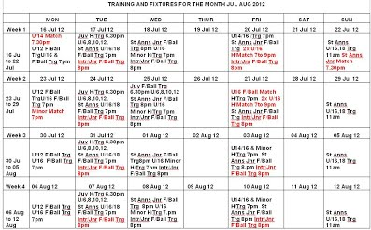
Click image to enlarge

Training & Fixture schedule for June/July
posted 28 Jun 2012, 10:16 by PRO St Pats,Tullow,Carlow
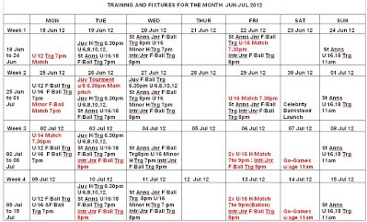
Click image to enlarge

Open Invitation to Celebrity Bainisteoir Reveal Day
posted 20 Jun 2012, 12:04 by PRO St Pats,Tullow,Carlow [ updated 27 Jun 2012, 12:58 ]
Please come on over to Bro Leo Park Tullow on Sat the 30th of June to find out who our clelbrity bainisteoir will be!

Sponsorship sought for the club
posted 14 Jun 2012, 15:15 by PRO St Pats,Tullow,Carlow [ updated 14 Jun 2012, 15:16 ]

St Patricks GAA are currently looking for sponsorship for pitch side signs which will be on display around our pitch during the filming of Celebrity Bainisteoir. Filming will begin on the Saturday 30th of June and we believe it will be a great opportunity for local businesses to show their support the club and also benefit from exposure to the crowds that will attend the match and probable television exposure.

By sponsoring our club you will get the opportunity to support a local GAA club whilst also increasing your profile to over one million viewers. In addition, if we get to the final we will get to feature in over 3 hours of prime time television and taking repeat shows into consideration this will rise to 9 hours of prime time television.

These signs will remain pitch side for the rest of the year. We will also be producing a programme for the first match be it home or away and we will be selling advertisements for this as well. So if you would like to benefit from such exposure and support your club at the same time, then contact Noel on 086-1966098. Your support would be greatly appreciated.

Celebrity Bainisteoir
posted 14 Jun 2012, 15:03 by PRO St Pats,Tullow,Carlow

On Friday the 8th of June we received the fantastic news that our club St Patrick’s will be getting the once in a life time opportunity of participating in the RTE production of Celebrity Bainisteoir. This news came on the back of many phone calls, emails and meetings with the production company over the last 5 months.

Celebrity Bainisteoir is a GAA reality programme which is now in it's 5th series and regularly features in the Top Ten of RTE programmes with over 600,000 viewers per episode. The series will follow 8 teams from around the country and their celebrity managers. There will be 4 quarter finals, 2 semi finals and the grand finale, which will be played in Parnell Park in Dublin. The games will take place between August and October. The filming for the series will take place from the end of June onwards. It is a knockout competition, so we will have to keep winning to progress. As of yet we do not know who our rivals will be as they haven't been chosen. The identity of our Bainisteoir is unknown and will remain so until the big reveal day on Saturday the 30th of June in Bro Leo Park, Tullow. The reveal will be a huge day for the community & surrounding areas with loads of fun activities planned, there will be something for everyone, and it promises to be a real family day out. The reveal will be followed by a training session with the Bainisteoir. Times are yet to be confirmed.

The venue for the first game will be chosen by a sports challenge between the two competing clubs. Four of our best athletes will be chosen to compete in this event against the opposing team. The winner will get to play in their home venue.

By appearing in Celebrity Bainisteoir we will receive massive exposure throughout the country and we will do our best to make the most of this opportunity.

It will also be a great community event and hopefully everyone will come down to the training sessions when the cameras are there and most importantly that they come to support the team on the big day.

For further information please visit our website www.stpatricks.carlow.gaa.ie
Or “Like” our Facebook page St Patricks GAA Club Tullow

Fame beckons for St Patrick’s GAA
posted 14 Jun 2012, 14:42 by PRO St Pats,Tullow,Carlow
By: Clare Minnock
GAA in Tullow might have taken a back seat to rugby, thanks to the meteoric rise of Seán O’Brien, but not anymore.
St Patrick’s GAA club has been confirmed as one of the contenders in the latest Celebrity Bainisteoir series on RTÉ.
The Tullow club got the call on Friday, and PRO Tadhg Madden admits it was quite the shock.
“I still can’t believe it. We don’t really know a lot yet but the buzz about the place is unreal. Everyone is delighted. It’s going to be a massive revival for the club,” added Tadhg.
The intermediate footballers will hit our small screens in September, with the big ‘reveal’ of their bainisteoir causing great speculation around the town.
Carlow’s celebrity circle is being touted as a potential hub for talent, with the likes of Seán O’Brien, Kathryn Thomas and even Saoirse Ronan among those who, we hope, could link up with the Tullow boys.
“We’ve no inkling at all on the celebrity. Hopefully, it’ll be someone good. We’ve no idea ‘til the day of the reveal, which is Saturday 30 June … they’re not telling us much,” laughed Tadhg.
The show, which will follow the club as they battle it out against seven other clubs for the CB title, has already given the club a great boost.
“We have massive numbers in training every night now. This will give us a great chance to raise our profile. It’s our time now – it’s a once-in-a-lifetime opportunity. There’s great enthusiasm and we’re going to make the most of it,” added Tadhg.
“The fun starts here.”
Tullow’s first game is on Sunday 12 August.

Celebrity Bainisteoir
posted 11 Jun 2012, 12:22 by PRO St Pats,Tullow,Carlow
We are delighted to announce that St Pats will be participating in this years series of Celebrity Bainisteoir!!!!!!

Carlow SFC team v Meath on Sunday
posted 7 Jun 2012, 10:22 by PRO St Pats,Tullow,Carlow [ updated 7 Jun 2012, 10:27 ]
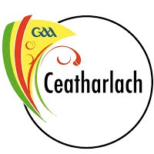
Congratulations to Padraig Murphy who has been selected to start at corner back for Carlow's championship opener against Meath on Sunday in Tullamore. Please go and support your fellow clubman! Throw in at 2pm.
Carlow SFC team v Meath on Sunday: Trevor O’Reilly; Padraig Murphy, Conor Lawlor, Brendan Kavanagh; Kieran Nolan, Shane Redmond, Tony Bolger; Brendan Murphy, Darragh Foley; Brian Murphy, Paul Reid, Eoghan Ruth; JJ Smith, Sean Gannon, Daniel St Ledger

County Board Draw Results
posted 5 Jun 2012, 10:12 by PRO St Pats,Tullow,Carlow
Two Club winners
Well done to John Fitzgerald and Anna & Tom Tracey on their win of €150.00

Cairde Ceatharlach C.L.G.

Draw 28th May 2012

 | Prize | Ticket No. | Winner | Club
1st Prize | Hyundai i20 or  €12,000 Cash | 6326 | Mrs Eithne Molloy,  Rathvilly | Rathvilly
2nd Prize | €2,000 Holiday Voucher or  €1,750 Cash | 4157 | Derek Kennedy, Fenagh | Fighting Cocks
3rd Prize | €1,000 Cash | 5934 | Mark Campion,  c\o Carlow Town | Carlow Town
4th Prize | €500 | 5852 | Peep c\o Ned Deane | Tinryland
5th Prize | €200 | 4903 | Paddy Gardiner, Bagenalstown | St. Andrews
6th Prize | €200 | 4347 | Declan Barron,  Highfield Carlow | Askea
7th Prize | €200 | 5907 | Carlow Town | Carlow Town
8th Prize | €200 | 6643 | James O’Brien,  Ballymurphy | Mt.L.R.
9th Prize | €200 | 4336 | Jennifer McAteer,  Brownshill | Askea
10th Prize | €200 | 4032 | Paul Flynn,  Grantstown, Waterford | Officers
11th Prize | €150 | 5085 | John Fitzgerald, Tullow | St. Patricks
12th Prize | €150 | 4021 | Tony McEvoy,  Cumas Hurling, Newry | Officers
13th Prize | €150 | 5774 | Dawn, Jackie, Mag, Nickey, C\O Supervalu Carlow | Palatine
14th Prize | €150 | 5912 | Leinster Ladies Gaelic Football | Carlow Town
15th Prize | €150 | 5056 | Anna Treacy, Tullowland | St. Patricks
16th prize | €150 | 5712 | McCullagh Jewellers, Bagenalstown | St. Andrews
17th Prize | €150 | 6216 | Therese Meaney, Leighlinbridge | Leighlinbridge
18th Prize | €150 | 4937 | Tommy Bambrick,  Royal Oak Road | St. Andrews
19th Prize | €150 | 5398 | Denise Clarke, c\o Roosters Fr. Cummins Park | Leighlinbridge
20th Prize | €150 | 6165 | Patrick Kealy, Borris | Mt.L.R.

Sports Predictor
posted 29 May 2012, 14:41 by PRO St Pats,Tullow,Carlow
Can everyone please return your Sports Predictor Sheets to Mairtin Mulooney No.1 The Rise Tullow ASAP!!

Bootcamp
posted 17 May 2012, 14:54 by PRO St Pats,Tullow,Carlow
Boot camp starting Tuesday 5th June for 12 weeks every Tuesday at 7.30 and sat at 10am. 7 euro per session or 100euro for the 24 sessions.1 class per week(12weeks) 60euro. 2 classes per week 10euro. Further details contact John 087-7956977
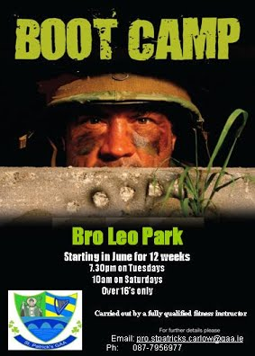

Training & Fixtures in Bro Leo Park for May & June
posted 17 May 2012, 08:57 by PRO St Pats,Tullow,Carlow
Click on image to enlarge
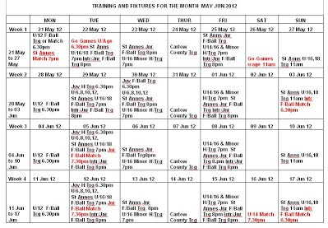

St. Patrick’s & St. Anne’s GAA Clubs will hold a Clothing Recycling Drive
posted 2 May 2012, 08:38 by PRO St Pats,Tullow,Carlow
Saint Patricks GAA Club

St. Patrick’s & St. Anne’s GAA Clubs will hold a Clothing Recycling Drive on
Sat 19 May 2012
To help Raise Funds for both Clubs

Please Donate all your Clean Unwanted Cloths, Bedlinen, Towels and Textiles including Shoes, Bags and Belts and Soft Toys
Mobile Phone are accepted But please keep them separate from Clothing & Textiles

Books are accepted BUT NO School Books(Text or Copy) Magazines or Diaries
NO Household Bric-A-Brac
Please Drop Items Off to

Club House Br. Leo Park between 9am and 1pm
On Sat 19 May 2012

Thank You for Your Support

For more information contact:
Club Secretary @ 086-1225491

Latest Fixtures for all teams
posted 30 Apr 2012, 09:59 by PRO St Pats,Tullow,Carlow
MINOR FOOTBALL CHAMPIONSHIP ‘B’ FIXTURES 2012

Date /Round | Teams | Time | Remarks
25/06/12 (Mon) R1 | Slaney Rangers v Clonmore | 19.00 | Br. Leo Park
16/07/12 (Mon) R2 | MLR v Slaney Rangers | 19.00
23/07/12 (Mon) R3 | Slaney Rangers v Naomh Eoin | 19.00 | Br Leo Park
09/08/12 (Mon) R4 | Fenagh v Slaney Rangers | 19.00
18/08/12 (Mon) R5 | Slaney Ranger v Michael Davitts | 19.00 | Br Leo Park
27/08/12 (Mon) R6 | Kildavin/Clonegal v Slaney Rangers | 19.00
10/09/12 (Mon) R7 | Burrin Ranger v Slaney Rangers | 19.00

UNDER 21 FOOTBALL CHAMPIONSHIP ‘A’ FIXTURES 2012

Date /Round | Teams | Time | Remarks
18/07/12 (Wed) QF | St. Andrews v Slaney Rangers | 19.00 | QF C
25/07/12 (Wed) SF | Quarter Final C v Quarter Final D | 19.00
22/08/12 (Wed) Final | Semi Final 1Winners v Semi Final 2 Winners | 19.00

INTERMEDIATE FOOTBALL CHAMPIONSHIP
GROUP ‘B’ FIXTURES 2012

Date | Teams | Round | Remarks
13/07/12 (Fri/Sun) | Clonmore v St. Patrick’s | Rd 1
20/07/12 (Fri/Sun) | St. Patricks v MLR | Rd 2
27/07/12 (Fri/Sun) | St. Patricks v Aska | Rd 3
17/08/12 (Fri /Sun) | Ballinabranna v St. Patricks | Rd 4
24/08/12 (Fri/Sun) | Fighting Cocks v St. Patricks | Rd 5

JUNIOR FOOTBALL CHAMPIONSHIP ‘A’ FIXTURES 2012

Date | Teams | Round | Remarks
07/08/12 (Tue) Q Finals | Old Leighlin or St.Andrews v St. Patricks

St Patricks County Board Draw tickets now available
posted 3 Apr 2012, 09:27 by PRO St Pats,Tullow,Carlow [ updated 3 Apr 2012, 09:27 ]
Tickets now available from our Secretary Mick O'Neill for €100 including 5 Spin & Win Tickets!
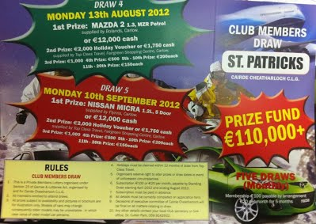

Training & Fixtures for April in Bro Leo
posted 26 Mar 2012, 15:39 by PRO St Pats,Tullow,Carlow [ updated 3 Apr 2012, 08:26 ]
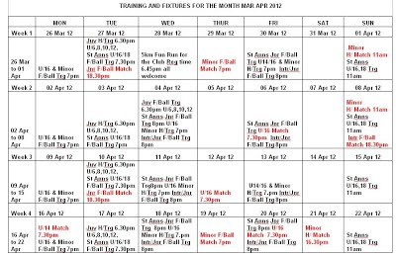

Fun Run
posted 26 Mar 2012, 14:12 by PRO St Pats,Tullow,Carlow
Reminder:
Please don't forget to attend the fun run this Wed 7pm in Bro Leo Park!!!!

Askea V St Patrick's this Sun 4.45pm
posted 9 Mar 2012, 13:58 by PRO St Pats,Tullow,Carlow
11-03-2012 (Sun) Askea V St Patrick's
Presentation College 16.45pm
Please come over and support the lads!

Slaney Rangers 5.10 - Burren Rangers 0.07
posted 9 Mar 2012, 13:55 by PRO St Pats,Tullow,Carlow
Well done lads, a great start for the minors last night

5km Fun Run/Walk
posted 8 Mar 2012, 13:39 by PRO St Pats,Tullow,Carlow
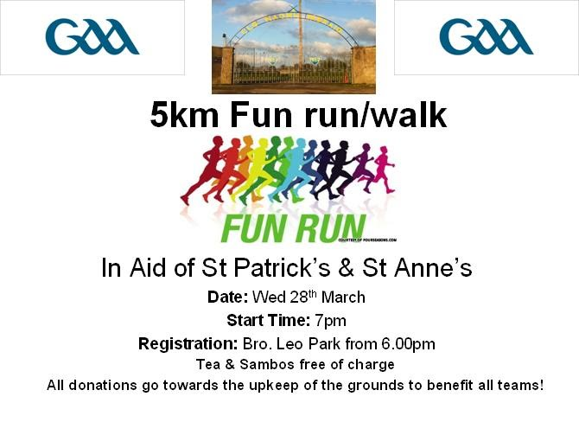

TRAINING AND FIXTURES FOR THE MONTH MAR 2012
posted 5 Mar 2012, 14:33 by PRO St Pats,Tullow,Carlow
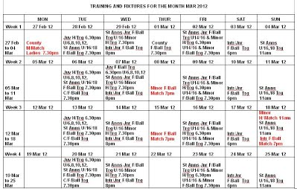

First League Game
posted 1 Mar 2012, 16:00 by PRO St Pats,Tullow,Carlow [ updated 9 Mar 2012, 13:57 ]
11-03-2012 (Sun) Askea V St Patrick's
Presentation College 16.45pm

Spin & Win
posted 29 Feb 2012, 21:12 by PRO St Pats,Tullow,Carlow

Next draw - Griffins Bar 12/03/12, Jackpot - €11,500

Winners
Draw | Jackpot |  | Winner | Winner  €100 | Winner  €50 | Winner  €25 | Promotor
27 February 2012 | €11,400 |  | No Winner | Annie Archibold | Caitriona Carroll | Michael Ricketts | Gay Griffin

Membership Due!!
posted 28 Feb 2012, 13:30 by PRO St Pats,Tullow,Carlow
Membership is now due, please arrange to pay tomorrow night in training at 8pm. Lorcan and Mick will be taking membership.
Also this is Darren Leonards first training session with the club, all players are asked to attend

5km fun run/walk 28th March
posted 26 Feb 2012, 19:52 by PRO St Pats,Tullow,Carlow

St pats mens and St Annes ladies coming together on wednesday 28th March at brother leo park for 5km fun run/walk starting 7pm. Welcome in the long evening and have tea and sandwich after in clubhouse! €5 donation to help teams,bring everyone prams and all!

Meeting new Manager Darren Leonard
posted 23 Feb 2012, 15:21 by PRO St Pats,Tullow,Carlow [ updated 23 Feb 2012, 15:22 ]
All players are asked to please attend a brief meeting with our new intermediate manager for the coming season - Saturday at 5.30pm.
This meeting will only take 15mins, training will commence as normal at 6pm with Shane Conlon taking his last session before Darren takes over fully next Wednesday night

